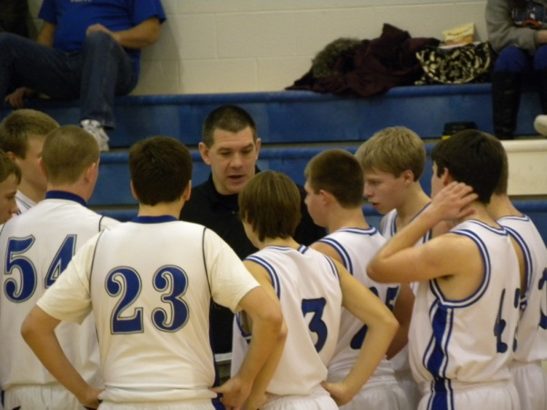
Also in this Edition:
- Poems
- Brag Book
- ReeceWear
- Insight on some Seniors
- Basketball Wrap Up
- Senora Interview
- Movie Review
Tournament Champions… By Reece Hiebert
With the conclusion of the 2011-2012 basketball season the JV team would just like to bring recognition to its greatest accomplishment of the season. This is the first time in the history of the Goessel JV entering this tournament that they have ever won this tournament. In the first round the JV faced the Lyon’s C team. The team struggled to find momentum or to pull ahead by a large amount in the first half. The second half started with the team focused and with the drive to win. The JV clenched the first round game with a win by 14 points. The next round presented a greater challenge for Goessel. Smokey Valley JV was more determined and much more athletic than Goessel’s previous opponent. The first half was a defensive show down with the score at halftime being 9 to 13 with Goessel up. In the second half the intensity picked up and Goessel had the drive and push for victory. Both teams tripled their points by the end of the game and Goessel claimed the upset victory 39 to 27. The bus was overloaded with enthusiasm after the win, and the preparation for the championship game. The Bluebirds would face Lyon’s JV team on their home floor for the championship, and the Lyons was hungry to win their home tournament. The game started off neck to neck and stayed so for most of the game. In the fourth quarter Goessel started to trail and fell down to the Lions by 8. With about two minutes left in the game Robi Kosa hit a huge 3 for the Bluebirds. After one free throw for the Lions Ben Wiens for Goessel made two three point plays back to back to tie the game at 41. Goessel stopped the Lions on their next possession and had a chance to win the game with about 10 seconds left in the game. With time running out Zach Showalter shot a 15 footer from the side and hit it to put the Bluebirds up by two. After the shot the clock went off and we thought the game was ours but there still was about a second and a half left on the clock. After three nerve-racking possessions and a last second shot attempt by the Lions the final buzzer rang and the Bluebirds were victorious.


Poem Corner
People and their disguises
All these people try to hide their faces with masks.
Most people so insecure with themselves,
That they try to wear a disguise.
Magazines sure don’t help.
A day’s insecurities is all you needed,
To feel bad about yourself again.
I don’t feel bad about myself,
So why are people beating me down?
I don’t talk bad about them,
So will someone please try to do the same?

Here with me
I look around and you are here for me,
I was just too stupid to see the signs.
You pick me up when I am sad,
Try to fix things when I’m in a bind.
You are the great comforter,
Just some people tend to be so blind.
I am so glad that I have found that out.
Thank you so much for being you.



State KMEA Orchestra
Reece Hiebert
Another year of hard work and dedication has paid off as three Goessel band students made it into state orchestra. Braden Unruh, Grant Flaming, and Reece Hiebert all were accepted into the state orchestra following their audition in Salina. For Braden, this was his third trip to state. He was recognized during the trip and given a medal for his accomplishment of making it in a state group every year it was available. The rehearsals were long and vigorous. All of us felt some pressure from our conductor when we all had solos or a key part. Being from Goessel we don’t usually hear string instruments or play with them, but in the orchestra they are everywhere. It was a good experience to work with them on the challenging music, and to try to make things come together smoothly. The time spent away from rehearsals with the guys was very memorable. There were lots of jokes and some pranks were pulled but what do you expect with seven teenage guys. We hope that the four seniors enjoyed their last trip to KMEA. (continued…page 3)


On the girl’s side, a 58-30 score was posted with Berean coming out victorious. Berean was undefeated coming into this contest. Jessica Harvey led scoring with 10 points, while Alex Hiebert led the team in rebounds with six. 4-16 is the regular season record the Lay Bluebirds will carry into substate against Burrton.
Written by Bruce Benjamin




Overmatched
On February 21st, the Goessel basketball regular season came to a close at Berean Academy. On the men’s side, Berean had only lost 1 game all season and came ready to play. After a final score of 48-20, a sour taste was left with the Bluebirds. Davis Cook posted a game-high 5 points while also contributing 8 rebounds and 3 blocks. Trey Schmidt led the team in assists and steals, even though both were only 2. Berean overmatched the Bluebirds and the final score reflected it. The Bluebirds end the season with a 11-9 mark heading into a substate matchup with Centre.


Battling at Burrton..
The Lady Bluebirds’ substate stay didn’t last long. Facing Burrton in the first round, the girls made it a game, but ending up losing 48-41 to the Burrton Chargers. Johanna Hoffman led the team with 14 points, while Alex Hiebert chipped in another 12. Jessica Harvey had a dominating 10 rebounds and 7 assists, while Aimee Flaming was able to contribute 5 steals in the game. Ali Buller also raked in 7 rebounds. Fouls proved to play a role in the Lady Bluebirds’ defeat, with the team accounting for 17 personal fouls. This game ends the Lady Bluebirds season. This year held a lot of hard fought battles for the lady Bluebirds and certainly ended sooner than they had hoped, we look forward to next year and what the girls can put together!
By: Bruce Benjamin

(Continued KMEA article..)
For the remaining three guys, we need some company for next year so try out if you’re in band or choir. Thanks to our chaperons; Mrs. Peters and Mr. Tierney, for putting up with us for almost three straight days. We appreciate all the work you two did to help make this trip special. State KMEA was a blast and we all look forward to next year.
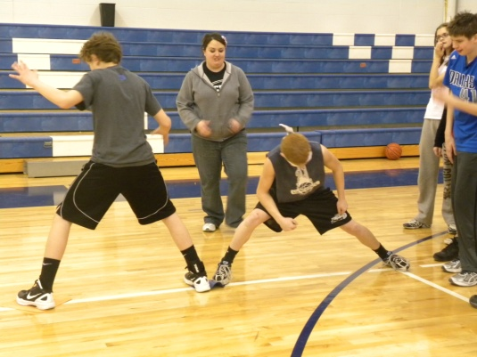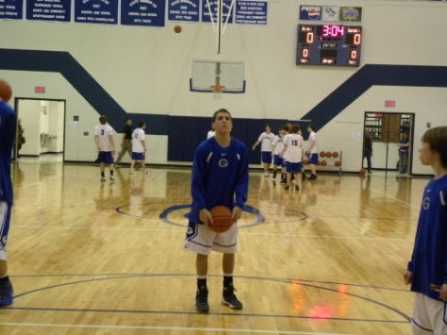
●●●
Students Travel to Topeka for Model UN
Early in the morning of March 5 before the sun had awaken for the day, the parking lot at Goessel High School had an unusually high level of activity. The cause for this ruckus was the brilliant souls who were departing for Topeka to compete in the Model UN event. I’m sure you have heard of the real United Nations, which is an organization formed by almost all the nations in the world with the purpose of keeping world peace and bringing impoverished areas resources for survival. This event is based on the real deal, with each school receiving countries and the students researching and basically becoming delegates from their country. Goessel received the countries of India, Benin, and Bulgaria. Students who are veterans of this event are required to write a “resolution”, or a plan to solve a major worldly issue and present in front of the other delegates in their council if it was accepted.
Most of the day was spent with the students dividing into their councils and debating with each other over who has the best idea to save the world and who is just blowing hot air. It can get quite lively during the debate process, and hilarious when one student loses their cool on another. I can’t speak for other students and their councils, but in mine there was clearly two “teams” formed at the beginning, splitting the people who have more conservative viewpoints from those who have liberal viewpoints. I know some of you probably are thinking this sounds really stiff and boring, but the topics of discussion can become pretty hilarious. One council decided the Twilight Saga was awful and needed to be ended, so there was a book burning all over the world. Last year we created a situation like “The Hunger Games” trilogy and had each country pick two kids to represent them in a gladiator fight. Obviously this is all hypothetical, and you shouldn’t really expect these things to be happening anytime soon.
I would recommend any student in the high school to join Model UN. You would enjoy participating in this if you have an interest in world news, have the urge to argue with other people just to see how frustrated you can make them, or have good public speaking skills and love to be the center of attention. Who knows, maybe you have the skills to actually become a United Nations delegate and will one day be doing this stuff for real. If you have questions about this organization you should ask Mr. ST or any of the participating students.
●●●

Joe Campbell—Last Bat
1. What is your favorite sport? “Football”
2. What is your favorite food? “Tacos”
3. What is your favorite car? “Dodge Charger”
4. Favorite HS memory? “…….”
5. Advice to underclassmen? “Learn to be quiet and listen to upperclassmen”
6. Freshmen are what? “There to be seen, not heard”
7. Most embarrassing moment? “…………”
8. Favorite thing to do while in the shop? “Mess with Tyler”
9. Future happenings? “College, AG , house, ETC.”

Making Memories with the Masterminds…
I recently went and talked some of the yearbook staff, and asked them basically a bunch of questions which summed up yearbook. The people I interviewed for this article includes: D’Ambra, Peter, Aimee, and Sam.
I interviewed 4 people, and the first person I interviewed was Mr. Peter Voth. I sat down and started talking to Peter, and I asked him, “Peter, what is the main jist of yearbook?” and had a short sweet reply to my question, and that was “ A way to incorporate the entire student body into a book that they can look back at in 20 years.” I was starting to get engaged into this conversation, when another question was brought up, because when I walked in they were having some delicious brownies and ice cream, and they decided that the Staff Meetings were the best thing about yearbook. Sam and Peter both decided that the hardest thing about yearbook was selling Ads, Aimee and D’Ambra both decided that working as a team and getting the deadlines in on time is the hardest thing, because they can sometimes bicker at each other and lose focus. I asked all of them what was the best thing about yearbook, and they all mainly said, that it was something that you get to look back on and say, “Hey, I did that, and everybody knows it.”
My final question for these year bookers was what is one thing that people assume about yearbook that isn’t true? And they all had a unique answer; Peter said, “That people assume it is an easy “A” and it isn’t!” Aimee said, “That it’s a girl class.” Sam said, “that we slack off and just mess around” and last, D’Ambra said, “That it is an easy class, or an overly hard class, as long as you work hard in the time your given, you won’t need to worry too much about the deadlines given to you”
-Connor Davis

Paige Booton
- What are your plans after HS? “Going to Tabor to play Volleyball, and study special ED.”
- Favorite pastime? “Volleyball”
- Favorite thing to do on your free time? “Read”
- Are you going to play any sports in HS? “I didn’t know I was getting held back and I would have to take High School again… thanks for the heads up”
- Favorite number? “9”
- Favorite teacher? “I refuse to answer this question”
- Favorite food/school lunch? “Philly-Cheese steak Sandwich”
- Most attractive celebrity? “Gerard Butler”
- Hardest class in your HS career? “ Government”
- Advice to underclassmen? “ Enjoy High-School while it lasts.”

The following is the end of season statistics for both the boys and girls varsity and junior varsity seasons. Look forward to the next edition where we feature golf and track season highs!
Boys Girls JV Boys JV Girls
Points Per Game: Braden 12.2 Jo 7.5 Ben 9.4 E.B. 3.1
Charity Stripe % Nic 74% Ali 78% Robi 100% Caroline 50%
Pulling the Most Rebounds Davis 156 Alex 113 Brian 114 Sam 46
Tossing the Rock (assists) Trey 45 Jess 52 Dan 28 Makalya 7
Congratulations for All League Selections! Braden received First Team Accolades and Davis and Jess received Honorable Mention nods. Way to go Bluebird athletes!

Senora Salmeron Speaks Out..
Hola! Como estas? This may be the extent of my Spanish knowledge but Goessel is lucky enough to have an expert! I conducted an interview with Senora to get to know a bit more about her.
Senora has been teaching for 37 years, 34 at Valley Center, and then she retired and later got a call from Goessel High School and we were asking her for a job, and then she came to Goessel and she has been teaching here for 3 rock solid years. While teaching at Valley Center she used to take some trips with students and also by herself, some of the places that she has been consist of; Spain, Costa Rica, and of course Mexico. I asked Senora what her favorite thing about going to these places was and she replied, “Meeting the people, main thing talking to them, understanding each other, mainly communicating with them, and learning the culture.” Senora went and got her college degrees at Wichita State, and also did some degree work at K-State University.
After HS people start deciding what they want to do as a profession, and senora always wanted to be a teacher, she said that when she was a child, her and her friends always played school, and she was almost always the teacher, and she would tell her “students” to sit down, and to do this and to do that. Senora was born and raised in a Suburb of Chicago, in Mount Prospect Illinois. She went to the local HS there and then went to those colleges I mentioned before.
The last two questions I asked senora was “What is the best thing about Goessel?” and, “Is there anything you would like the student body to know about you that is interesting?” and the first one should make everyone of us students feel very special because she said “That the kids haven’t lost their innocence, and that they are enjoyable, fun and not bad.” And then the last question, I know we all wanna know something interesting about our teachers, and her last response was, “That Spanish is an important and interesting and fun class, and that it is a fun language, and that I takes a lot flamenco lessons, originated from Spain, and it is very hard.”
So, after reading this article I hope that we all have learned a little bit something new about Miss. Senora Salemeron.
-Connor Davis

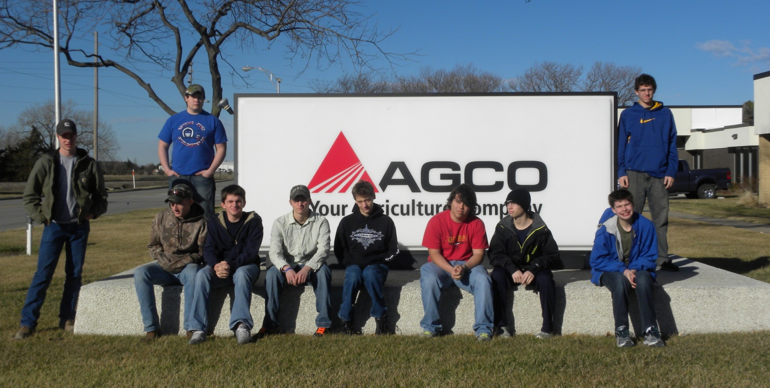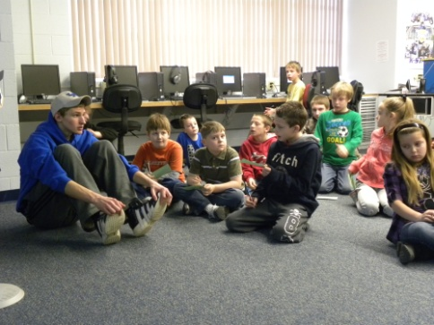
National FFA Week
Reece Hiebert and Bruce Benjamin
The FFA chapter has finished celebrating National FFA Week. The week started out with a chapter lock in conjoined with the FCCLA chapter from Sunday night onto Monday morning. The chapters participated in leadership games, ate some good snack food and lost a lot of sleep. On Tuesday the FFA honored the faculty with an appreciation breakfast. Thanks to all the FFA members that came early in the morning to help prepare the food. It helped things run smoothly. The following day the FFA members were invited to drive their tractors to school. Many FFA members took advantage of the offer and crowded the parking spaces by the shop.
On Thursday, the Goessel FFA chapter took industry tours all morning. First was a visit to the Canton Locker, where local FFA superstar Joe Campbell works. FFA members learned the insides and outsides of how a meat locker works, getting to experience up close and personal all equipment used in the locker. The other industry toured was Agco in Hesston. Agco is a huge agriculture manufacturer, making many local products to be sold and used on farms. Members learned how these products are made and just how big the whole company was!
On Friday, the FFA celebrated FFA week by having a party during Academic Skills, where members go to come to the shop and hang out with friends. Later the night, the chapter had a meal at Pizza Hut in Newton then went cosmic bowling to celebrate FFA. As the night wore on, bowling battles ensued, when the competition became fierce.
On Saturday, the final day of FFA week, the chapter hosted its annual pancake feed. Members cook pancakes, bacon, sausage, and orange juice for the Goessel community and fed them based on a free will donation. The chapter enjoyed some great breakfast food and gaining publicity for their March 30th work auction. Overall, FFA week went very well for the Goessel chapter and was a success for FFA everywhere!

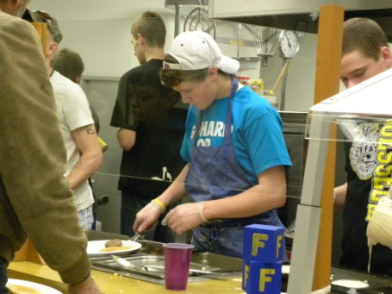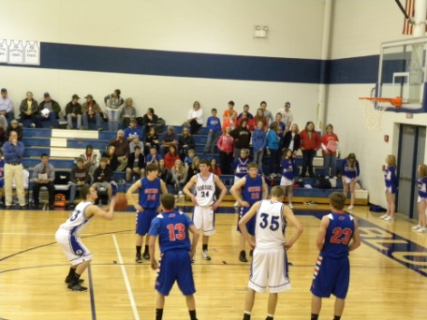
ReeceWear
SpringWear Edition
Well ReeceWear fans spring is upon us and it’s time to break out the spring clothing. Now I know this isn’t a real problem for girls, but I’m not an expert on girls fashion so I’ll leave this up to you. Now back to the guys, there is the day old question of ‘How short is to short’ I am here to try to spread a little light on this question. The spring time is a great time to wear shorts, but sometimes that favorite pair of shorts is getting, well short. There are a couple of different options for this; the first would be to sag. Being of the farmer dress origin I am unfamiliar to this form of dress but if it works for you, great. Everyone wants to see your boxers. The second option is to just grin and bear it. Take things with a grain of salt. Fight through the embarrassment and make it through the day without ridicule. Or the third option is to just let them go. All good things have to come to an end; spring break has to end, sports seasons end, and people grow out of shorts. It will be ok, I promise. As the founder of the ReeceWear product line, or just having the courage to wear these clothes out in public, I can say with confidence that ReeceWear supports all types of shorts, just not the real short ones. Now shorts can look ridiculous if you match them with the wrong accessories. Shorts can’t go with long socks. This is not fashionable so take my advice as the school’s self-proclaimed fashion expert; invest in short socks for spring, summer, and fall. This is the only time extra short is acceptable. Belts for shorts are also a good idea and can really avoid unexpected sagging. So just remember as you all dig out the shorts for the spring season to check to see if it is ‘to short’, and that a good pair of shorts needs the right accessories. This has been Reece Hiebert with ReeceWear.

The hangover on steroids!!!
If you haven’t gotten a chance to see Project X yet, do the following:
- Stop reading this
- Run out of the school
- Get to your local movie theatre!
Project X is a movie, based off a real story, where three 17 year olds in high school are considered outcasts and want to become popular in their school. By hosting a “big” party, the protagonist Thomas asks his friend to help spread the word about this party. Word of the party spreads a little too much; being advertised on craigslist and over the radio just scratches the surface of the announcement of this epic party. A party located in North Pasadena, California, turns out to get out of hand as over 1500 people show up to this small neighborhood kid’s party. Being teenagers, they continue their wild and crazy party, one that is historically unmatched by the likes of high schoolers. The party concludes with an epic finish; one that leaves Thomas in a predicament about his night of fun.
A lighthearted comedy, Project X comes to being the viewer into a state of mind within the movie, submerges them into the plot, and brings up memories of each viewer’s own wild night. This movie also gets the Seal of Approval!!
Project X scores a 10/10. By: Bruce Benjamin
ByB

